**In Reception children are learning**:

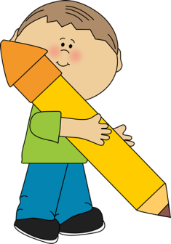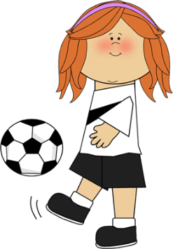

**Communication and Language**

* To join in with reading familiar stories, such as The Three Little Pigs.
* To talk about the events in these stories, explaining how and why things happen.
* To concentrate on an activity and focus our attention.
* To develop our range of vocabulary
* To use language to create role play games, such as vets or firefighters.

**Communication and Language**

* To learn and use new vocabulary
* To talk about events in detail and in sequence
* To listen to stories and talk about them
* To retell familiar stories
* To enjoy fiction and non fiction books
* To learn rhymes, poems and songs

**Personal, Social and Emotional Development**

* To be resilient and keep trying when challenges occur
* To build respectful relationships
* To understand and talk about our feelings and behaviour and that of others.
* To manage their own feelings and behaviour

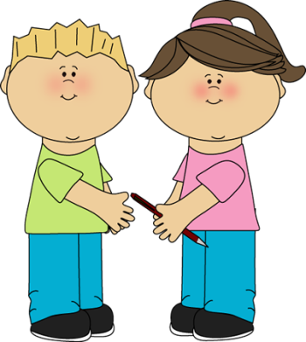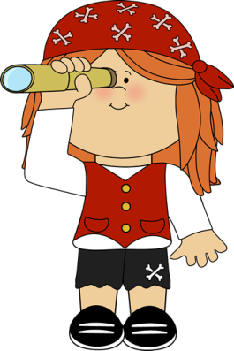

**Physical Development**

* To move with increasing skill and control in a range of ways, such as hopping, skipping and jumping.
* To use a range of balls, beanbags, hoops and other equipment with increasing control.
* To hold a pencil with good control and use it to form letters correctly.
* To know how to stay fit and healthy.

**Mathematics**

* To count actions, objects and sounds
* To count beyond ten and compare numbers
* To understand and recall one more and one less.
* To recall number bonds to ten
* To play with, sort, name and describe a range of shapes
* To continue, copy and create repeating patterns
* To compare length, weight and capacity

**Literacy**

* To recognise the single letters and say the sounds made by them
* Learn the single sounds made by more than one letter (i.e. sh, ch, oo)
* To hear and say sounds in the words and use these to write words and sentences.
* To blend sounds together to read words and sentences
* Form letters correctly
* Use capital letters and full stops









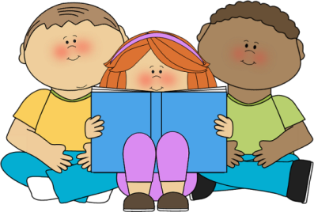

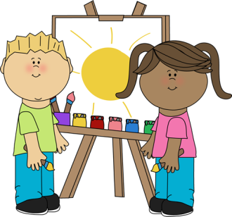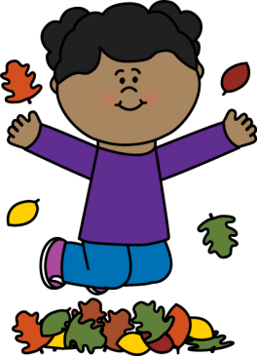

**Expressive Arts and Design**

* To create as part of a group, sharing resources and ideas
* To discuss their feelings and responses to music
* To create narratives in their play
* To make music and dance
* To sing songs, matching the pitch and melody

**Understanding the World**

* To talk about their own family and community
* To comment on images from the past
* To understand that some people have different beliefs and ways of celebrating
* To explore the natural world.
* To compare different environments
* To describe what they see, hear and feel whilst outside

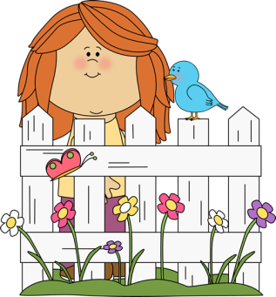

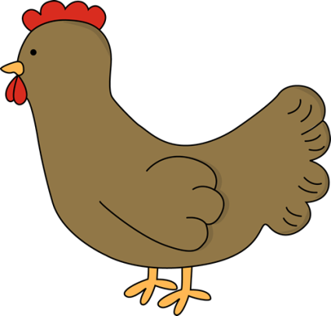

**Topics**

The above areas of learning are taught through a range of topics. The topics will be based on children’s interests and therefore will vary each year based on the particular interests in the class. Popular topics often include:

* People Who Help Us
* Holidays
* Transport
* Space
* Pirates
* Seasons
* Dinosaurs
* Minibeasts
* Farms
* Traditional Tales
* Pets
* Under the sea.

